**Q1.** **WACP to calculate the sum of first n odd numbers (using while loop).**

#include <stdio.h>

int main(){

int num, sum = 0, i = 1;

printf("Enter any number: ");

scanf("%d", &num);

while(i <= (num + (num - 1)) )

{

if(i % 2 != 0)

{

sum = sum + i;

}

i++;

}

printf("The sum of first %d odd numbers is %d\n ", num, sum);

return 0;

}

**Output:**

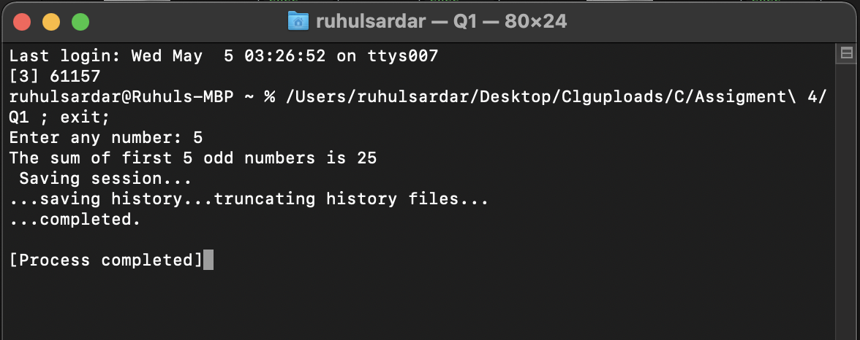

**Q2.** **WACP to calculate factorial of a number without using recursion**

**(using do while loop).**

#include<stdio.h>

int main(){

int num,i = 1 ,fact = 1;

printf("Enter any number: ");

scanf("%d", &num);

do{

fact = fact * i;

i++;

}while(i <= num);

printf("The factorial of %d is %d\n", num, fact);

return 0;

}

**Output:**

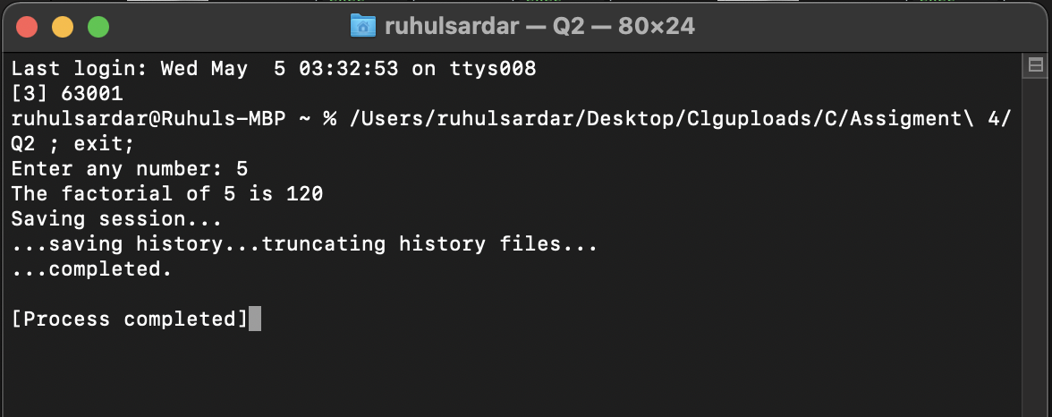

**Q3. WACP to print the Fibonacci series without using recursion (using for**

**loop).**

#include<stdio.h>

int main(){

int n1 = 0, n2 = 1, n3, i, num;

printf("Enter the number of terms to be printed: ");

scanf("%d", &num);

printf("\n%d\n%d\n", n1, n2);

for(i = 3; i <= num ; i++)

{

n3 = n1 + n2;

printf("%d\n", n3);

n1 = n2;

n2 = n3;

}

return 0;

}

**Output:**

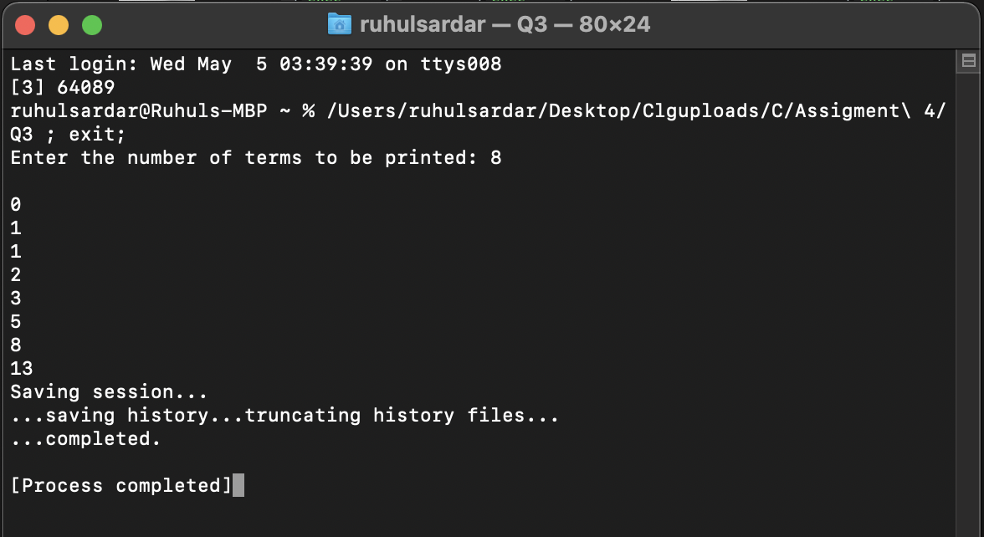

**Q4. WACP to find whether a number is Armstrong or not (using while and**

**if statement).**

#include<stdio.h>

int main(){

int num, temp, res = 0, rem;

printf("Enter any number to check if it is an armstrong number: ");

scanf("%d", &num);

temp = num;

while( temp != 0)

{

rem = temp % 10;

res += rem * rem * rem;

temp /= 10;

}

if( res == num )

{

printf("%d is an armstrong number\n", num);

}

else

{

printf("%d is not an armstrong number\n", num);

}

return 0;

}

**Output:**

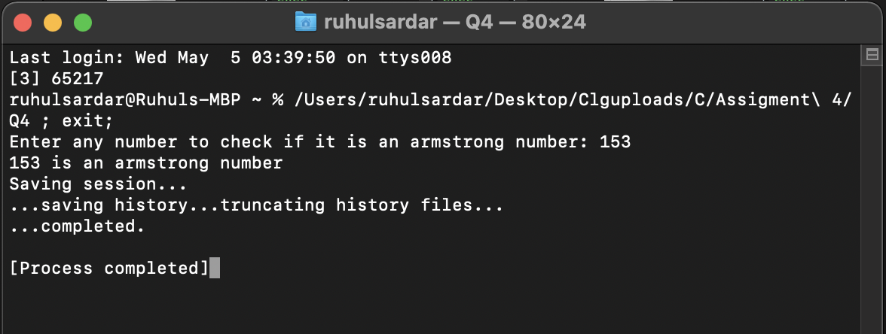

**Q5. WACP to check whether a number is palindrome or not (using while**

**and if statement).**

#include<stdio.h>

int main(){

int num, temp, res = 0,rem;

printf("Enter any number to check if it is palindrome: ");

scanf("%d", &num);

temp = num;

while( temp != 0)

{

rem = temp % 10;

res = (res * 10) + rem;

temp /= 10;

}

if ( res == num)

{

printf("%d is palindrome\n", num);

}

else

{

printf("%d is not palindrome\n", num);

}

return 0;

}

**Output:**

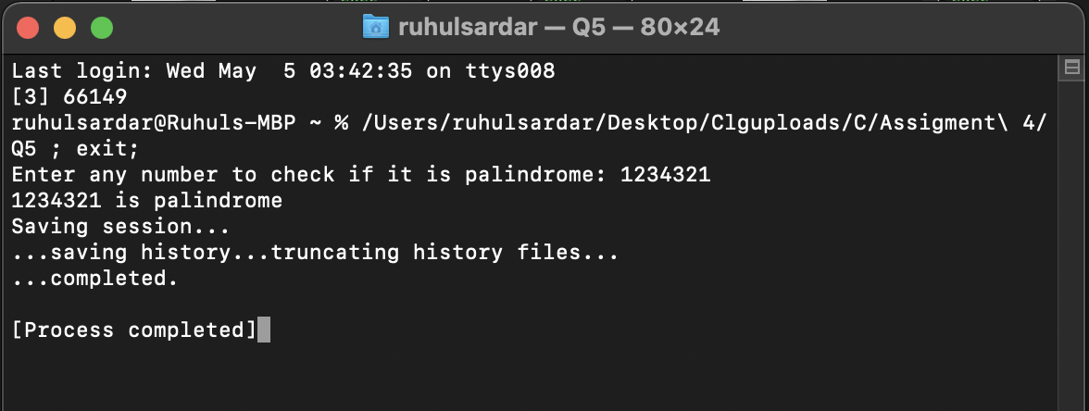

**Q6. WACP to find whether a number is prime or not (using for and if**

**statements).**

#include <stdio.h>

int main() {

int n, i, c = 0;

printf("Enter any number n:");

scanf("%d", &n);

for (i = 1; i <= n/2; i++)

{

if (n % i == 0)

{

c++;

}

}

if (c == 1)

{

printf("%d is a Prime number\n", n);

}

else

{

printf("%d is not a Prime number\n", n);

}

return 0;

}

**Output:**

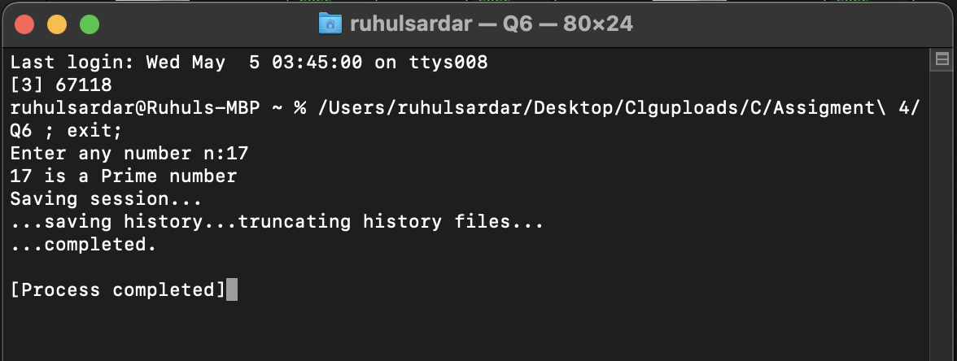

**Q7. WACP to print the first n integer numbers divisible by 7 (using for and**

**if statement).**

#include<stdio.h>

int main(){

int num, i;

printf("Enter the number of terms: ");

scanf("%d", &num);

for( i = 1; i <= (num * 7); i++ )

{

if(i % 7 == 0)

{

printf("%d\n", i);

}

}

return 0;

}

**Output:**

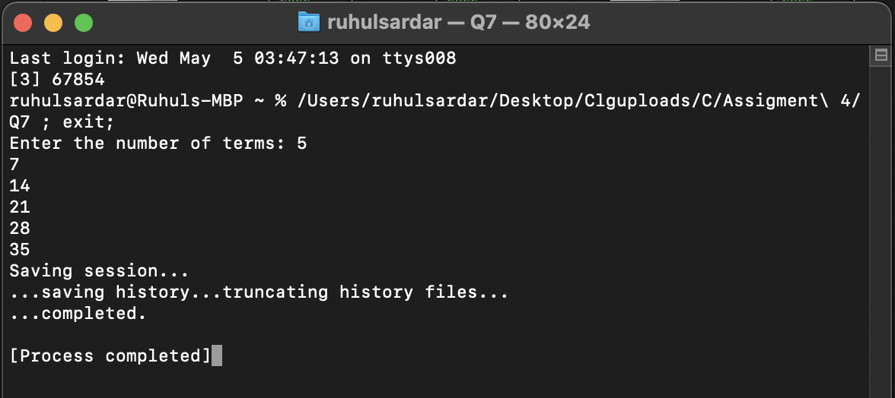

**Q8. WACP to print the first n integer numbers not divisible by 7 (using for**

**and if statement).**

#include<stdio.h>

int main(){

int num, i,temp ;

printf("Enter the number of terms: ");

scanf("%d", &num);

temp = num / 7;

for( i = 1; i <= num ; i++ )

{

if(i % 7 != 0)

{

printf("%d\n", i);

}

}

for(int j = i ; j <= i + (temp - 1); j++)

{

printf("%d\n", j);

}

return 0;

}

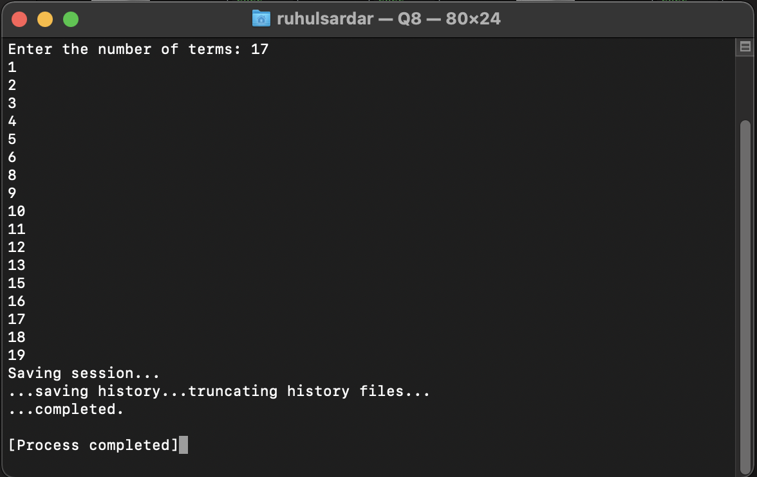**Output:**